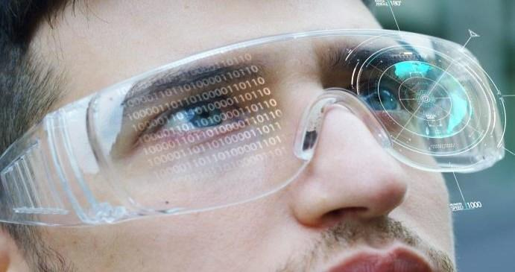

Session 1

Introduction and Setting Up of VR Packages

Welcome to the session, **Introduction and** **Setting Up of VR Packages**.

This session gives an introduction to Virtual Reality (VR), Augmented Reality (AR) and also illustrates how to set up VR Packages.

In this session, students will learn to:

* Define Virtual Reality and Augmented Reality
* List the different types of VR headsets and Platforms
* Explain the launch of a new VR project
* Illustrate how to import the required Packages for VR application creation

Over the last few years, the growth and excitement of VR have increased tremendously with the usage of games such as Pokemon Go or the next social media Meta Verse. It is easy to be lost in all the buzz and forget the actual meaning of VR so let us take a look at what VR actually is.

1.1 Introduction to Virtual Reality

VR is the technology that mimics the real world or fantasy environment with the use of 3D environments inside a program such as Unity.

A VR headset, a specialized device mounted on the head is used to capture data such as rotation, head movement, tracking, and so on, which then is used by the VR Application to simulate accurate movement for virtual cameras in the simulation which gives the illusion that a user is actually in that environment. This tech is useful in several fields such as training, Simulation, Entertainment, Meetings, and Business to name a few.

It is possible to just use a normal application on the desktop but the immersive experience in VR is far better as compared to a simple application.

1.2 Introduction to Augmented Reality

While VR tries to put a user in a virtual environment, AR on the other hand does the exact opposite by putting the virtual environment for real. It takes the video recorded through the camera and after tracking, puts a Virtual 3D model on top of it so that it appears as if the model actually exists in the real world.

The tech behind VR and AR is quite similar and different at the same time.

Although AR/VR often come up together that does not mean that they are the same or are always used together, each can work independently of the other.

AR is particularly useful when someone requires to get an idea of how something would look if placed in the world. For example, let us say an Interior designer wants to see how certain placement and furniture would look, they can use AR to put virtual models in the scene and get a feel of how it would look in real life without waiting for several hours to get the results from either Render or actually putting the furniture in place.

1.3 How to Develop VR Games and Applications

Unity is a great choice if you want to build VR Games and Applications for VR Headsets or other platforms. Unity provides flexible tools and resources to create a VR application for any purpose. Figure 1.1 shows a VR application inside Unity.

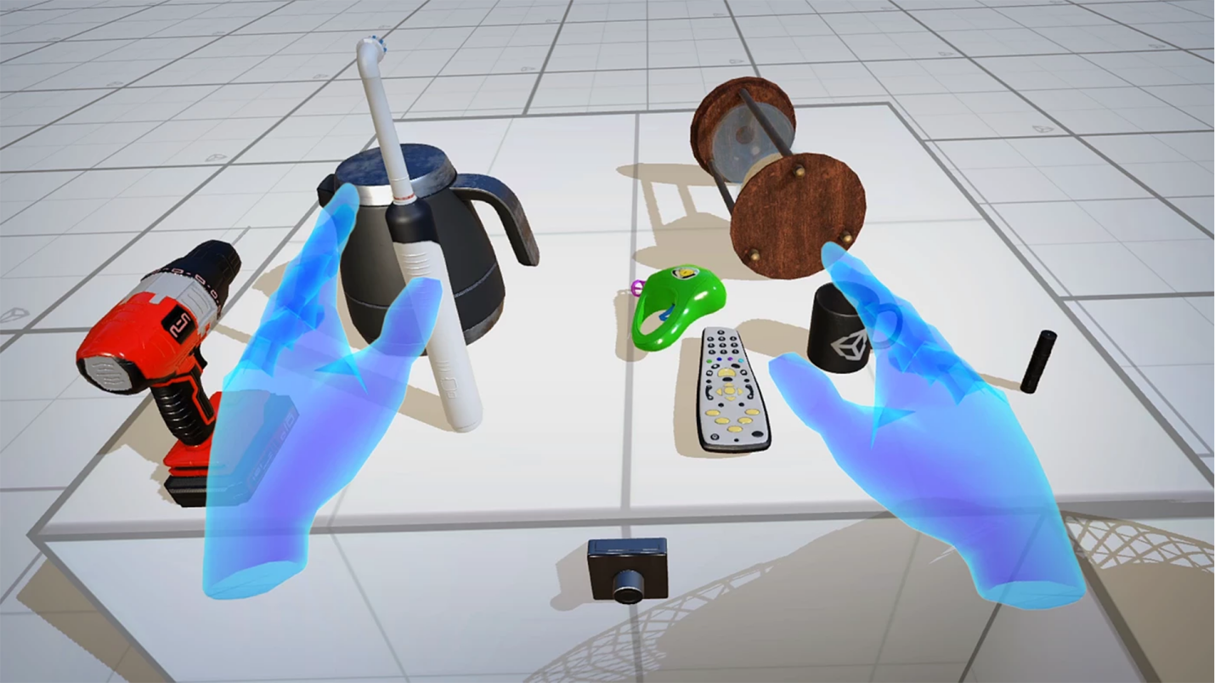

**Figure 1.1: A VR application in Unity**

***Image Courtesy: Unity***

It can be used to develop several platforms such as Oculus Rift, Steam VR, PSVR, IOS, Android, and many more. Unity has ready-to-use plugins for AR/VR for Android, IOS, and other platforms to easily start developing without any hassle.

Since AR/VR is a specialized sub-domain, Unity does not have all the required tools pre-installed; Instead, Unity provides easy-to-use and installable templates of AR/VR Games and Applications which the user can use to set up AR/VR projects inside Unity.

Unity handles all the tracking and camera movement so the user might not have to care about the camera movement and its program.

1.4 Different Types of VR Headsets and Platforms

A VR headset uses several sensors and techniques to find the position and rotation of the headset in the world. Gyroscope, Accelerometer, Ultrasonic rays, Infrared rays, and Cameras are used to accurately find the position of the Headset in the real world.

Most headsets also come with a **Controller** which is also tracked in a similar fashion and serves the purpose of interacting with the virtual world.

Additionally, some controllers such as PSVR2 also track individual fingers to provide a better immersion experience.

**6DOF**:6DOF which stands for **6 Degrees of Freedom** allows for tracking both rotation and position of the headset in forward, backward, up, down, left, and right directions.

**3DOF**: It stands for **3 Degrees of Freedom** and allows rotational tacking in X, Y, and Z axes using the gyroscope sensor.

Several companies have VR technology hence, there are several types of VR headsets and Platforms.

Following are different types available:

1. **Standalone**: These devices have everything inbuilt. The most popular example is **Google Cardboard**, a VR box made up of a Cardboard where the mobile device acts as the VR device. It is one of the most easily accessible platforms available. Figure 1.2 shows a Google Cardboard platform.

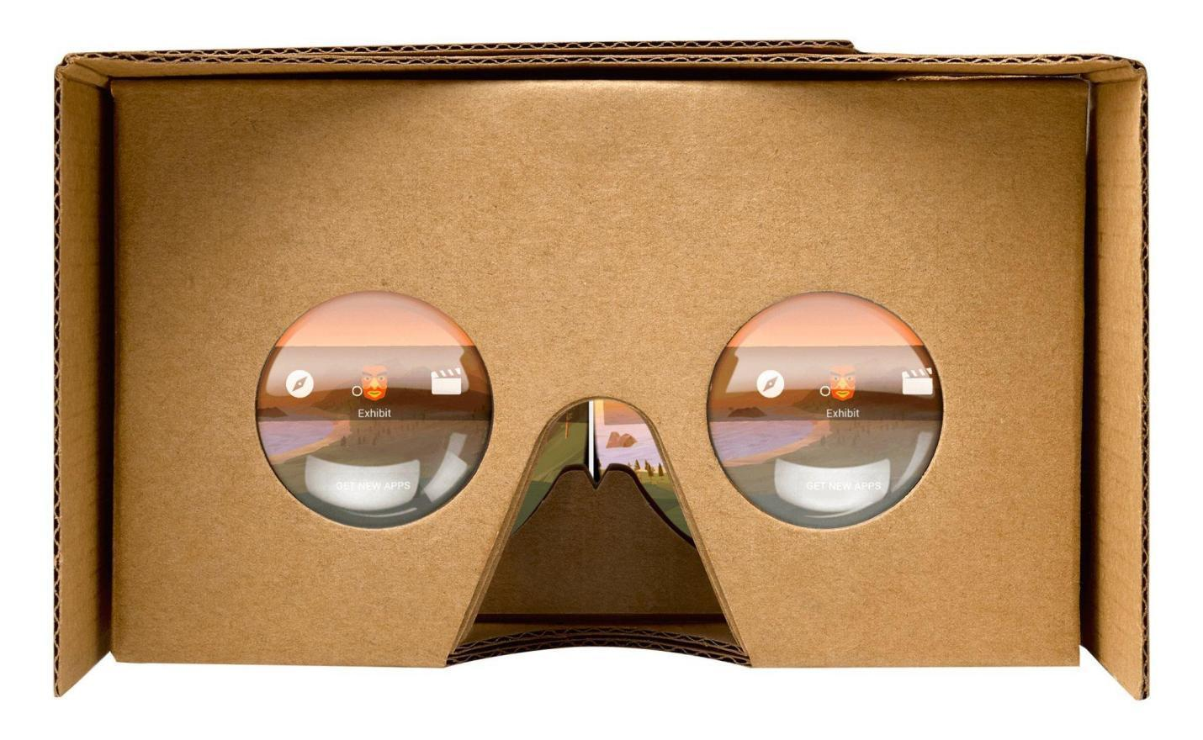

**Figure 1.2: Google Cardboard**

***Image Courtesy: Amazon.com***

1. **Tethered**:These devices act as display devices and are connected to other devices, usually a powerful PC for processing. These **Head Mounted Displays (HMDs)** often come with remotes supporting hand tracking and even finger tracking. The tracked data is fed to the computer as input.

There are many devices in this category, including PSVR, Meta Quest 2, and so on. Let us see them one by one.

* **PSVR**: It is developed by Sony for their Consoles PlayStation 4 and PlayStation 5. Another VR headset called **PSVR2** was released recently for their latest Console PlayStation 5 with more features such as finger tracking, custom play area, foveated rendering, and more. Figure 1.3 shows a PSVR headset.

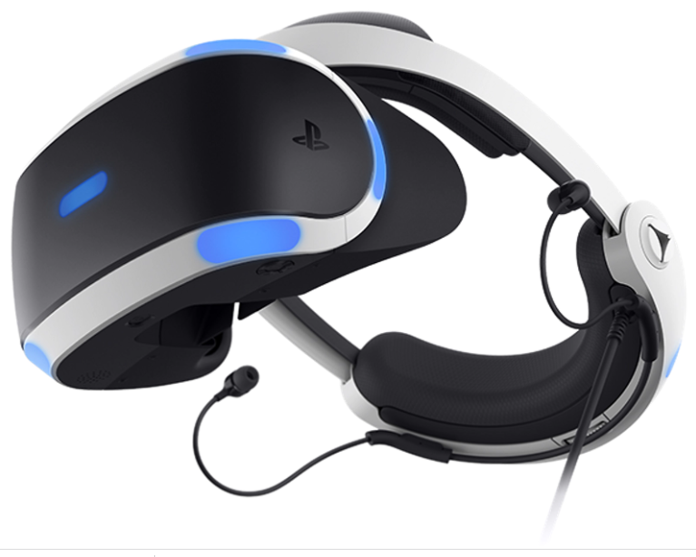

**Figure 1.3: PSVR - Sony PlayStation**

***Image Courtesy: PlayStation.com***

* **Meta Quest 2**: This headset can act as a standalone or tethered HMD. You can play your PC games after connecting the Headset to the PC. It comes with two motion controllers for hand tracking. It is one of the most popular VR in the market. Figure 1.4 shows the Meta Quest 2 headset.

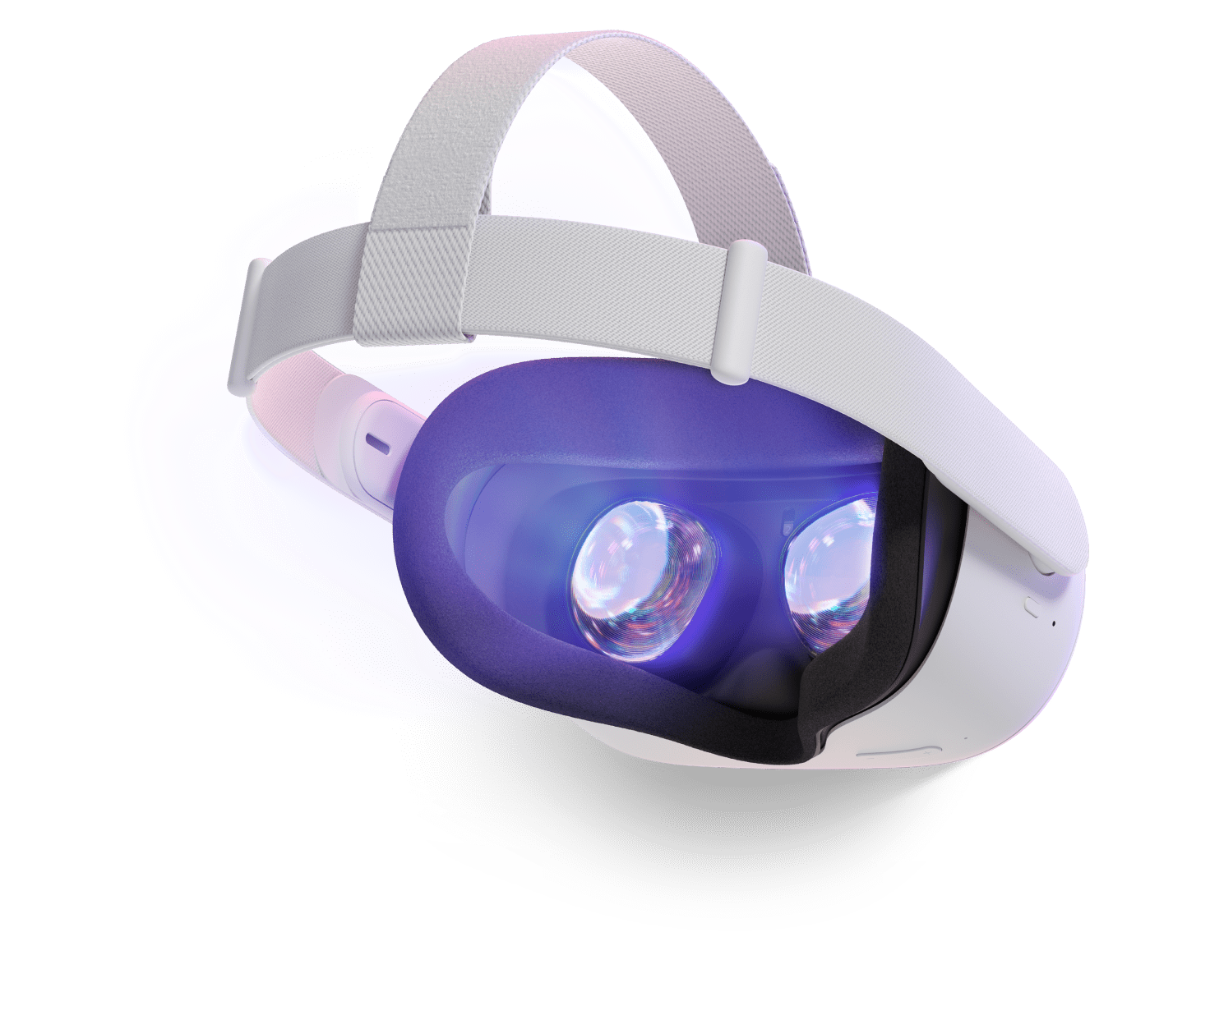

**Figure 1.4: Meta Quest 2 - Meta**

***Image Courtesy: Meta***

The way one consumes digital material has been completely transformed by VR and Unity is a great platform for creating such VR applications.

1.5 Create a New VR Project with Unity

Setting up the required VR packages is vital if you want to develop VR applications in Unity. To set up VR packages in Unity, the user must create a new VR project.

Follow these simple steps to set up a VR package:

**Step 1**: Open the Unity Hub and click the **New project** button as shown in Figure 1.5.

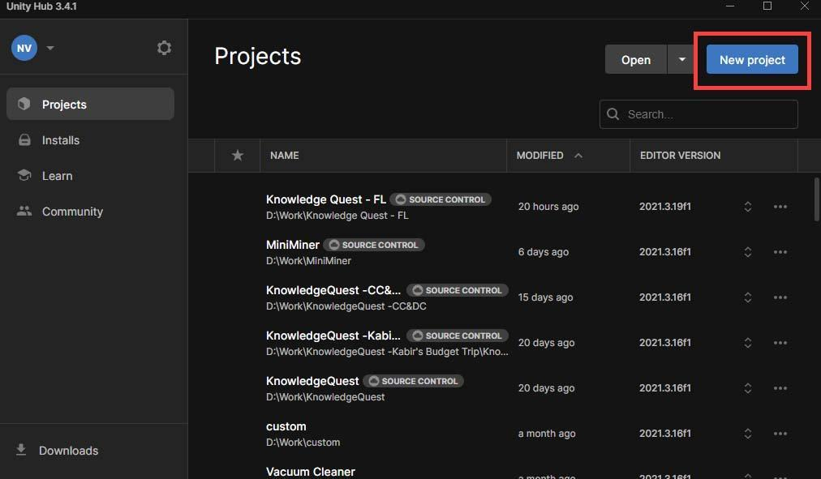

**Figure 1.5:** **Location of the New Project Button**

**Step 2**: Choose the **3D** project template, name the project, and specify where to save it as shown in Figure 1.6.

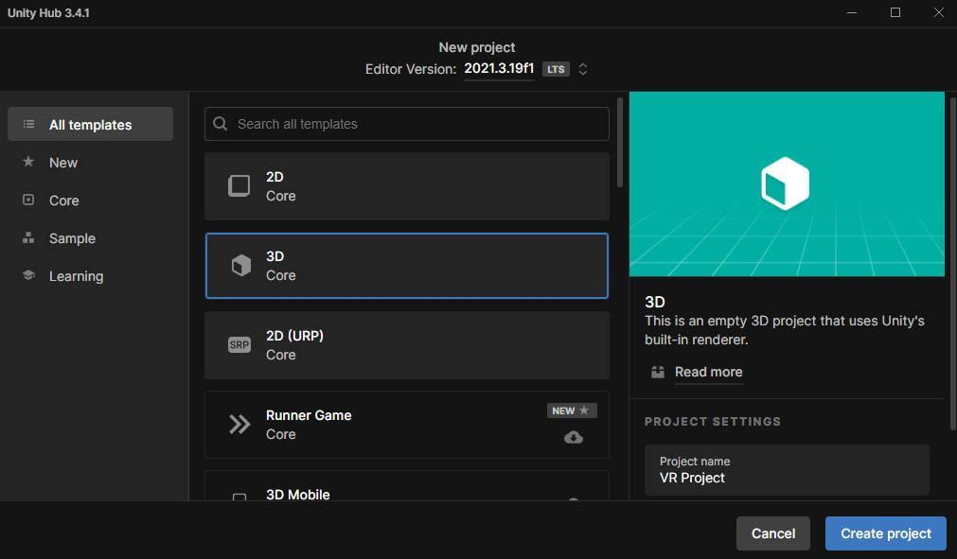

**Figure 1.6: Save the Template**

**Step 3**: Click the **Create project** button to create a new VR project as shown in Figure 1.7.

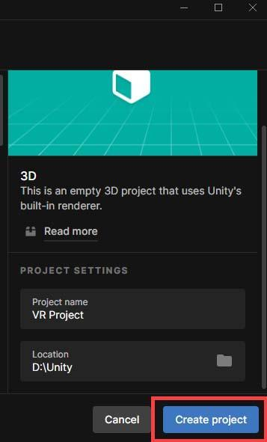

**Figure 1.7: Location of the Create Project Button**

**Step 4**: Unity will set up the necessary settings and default packages for the 3D project as shown in Figure 1.8.

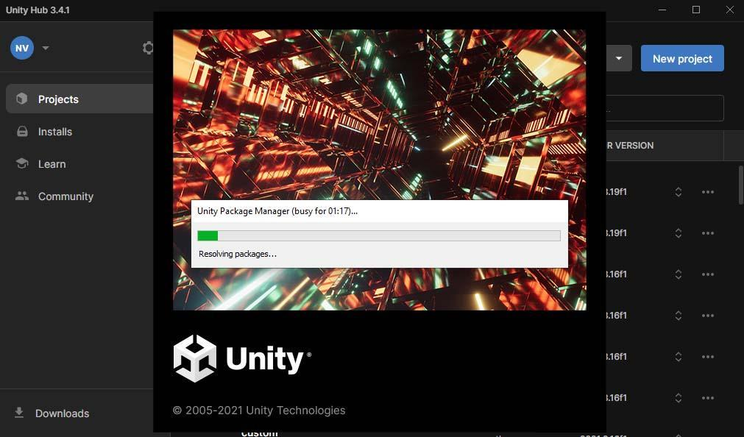

**Figure 1.8: Unity Setting Up the Project**

1.6 Import the Required Packages for VR Application Creation

After creating a new VR project, you must import the necessary packages to build VR applications.

Follow these simple steps to import the packages:

**Step 1**: Launch the Unity Editor and select **Edit** from the menu as shown in Figure 1.9.

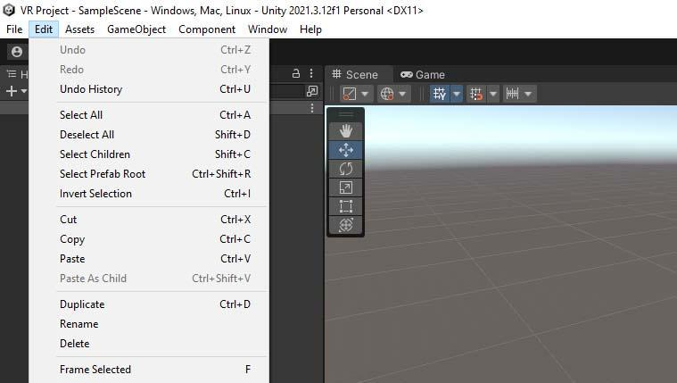

**Figure 1.9: Location of Edit**

**Step 2**: Choose **Project Settings** and then choose **XR Plugin Management** as shown in Figure 1.10 and Figure 1.11.

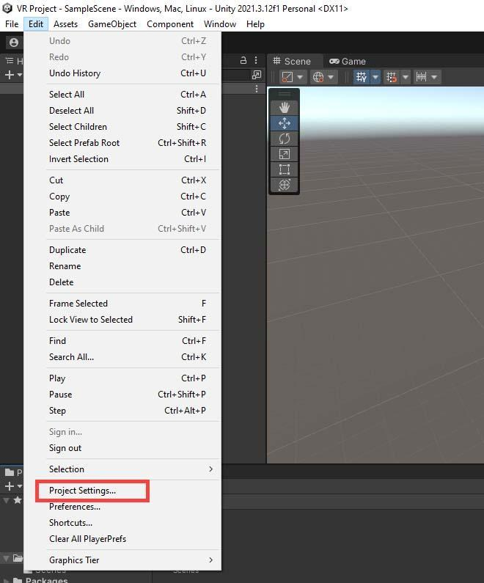

**Figure 1.10: Location of Project Settings**

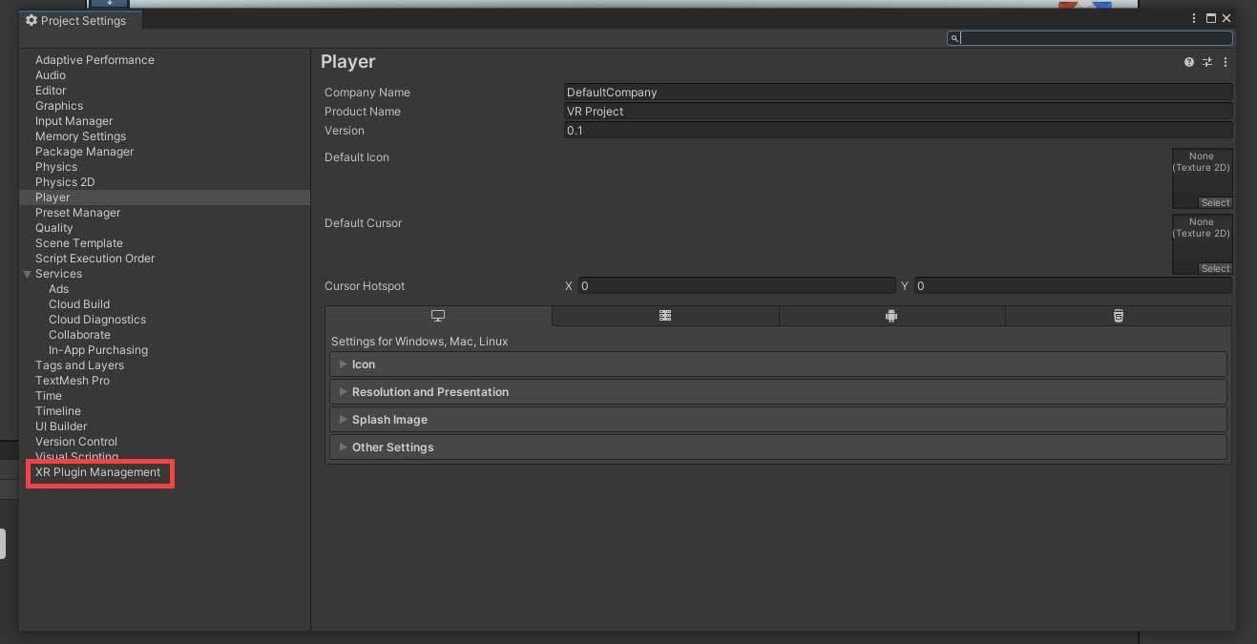

**Figure 1.11: Location of XR Plugin Management**

**Step 3**: Click the **Install XR Plugin Management** button to begin installing the software as shown in Figure 1.12.

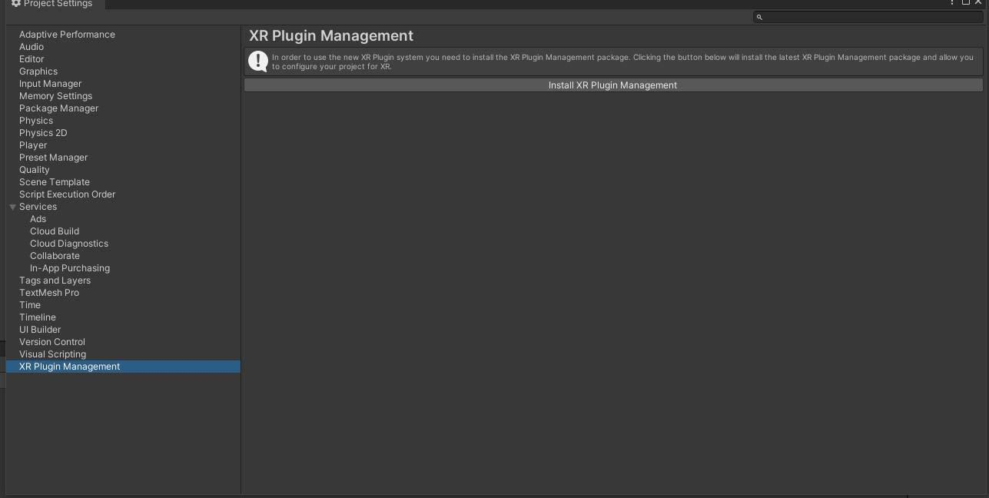

**Figure 1.12: Location of Install XR Plugin Management Button**

**Step 4**: Check a Plug-in provider based on the VR headset as shown in Figure 1.13.

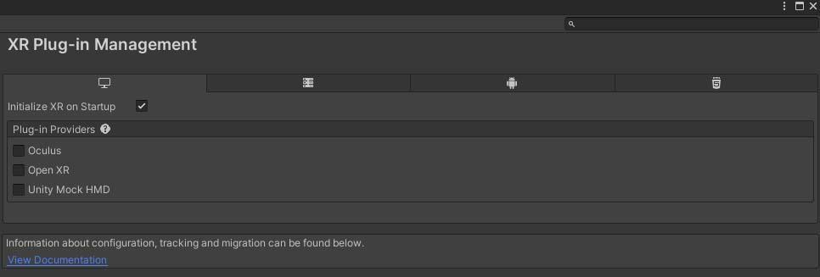

**Figure 1.13: List of Plug-in Providers Provided by Unity**

**Step 5**: Click the **Yes** button on the warning dialog box as shown in Figure 1.14.

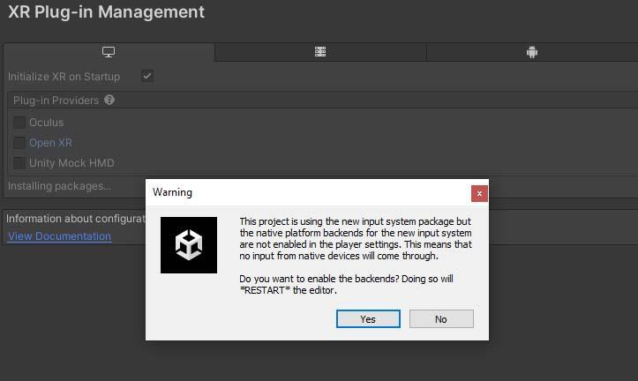

**Figure 1.14: Warning Message**

**Step 6**: Choose **Open XR** under **XR Plugin Management** and then click the plus (**+**) sign for adding an interaction profile as shown in Figures 1.15 and 1.16.

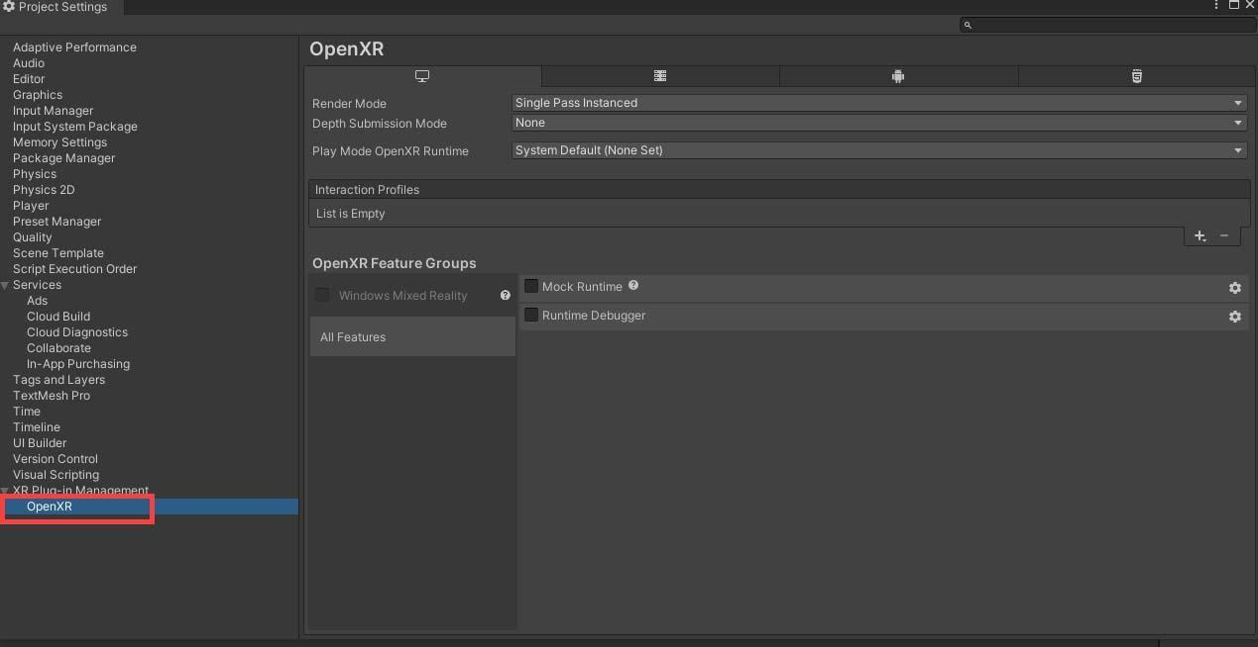

**Figure 1.15: Location of OpenXR Tab**

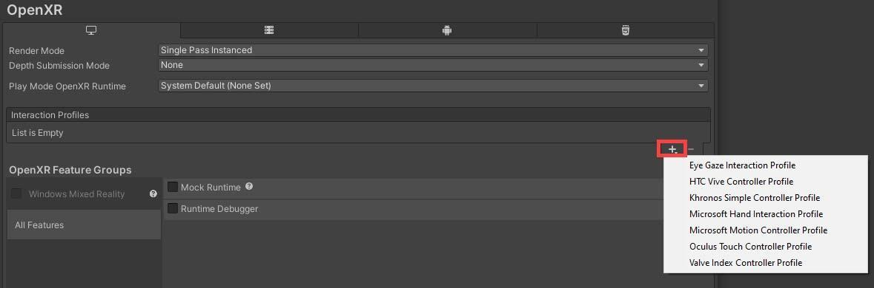

**Figure 1.16: Location of Plus Sign to Add an Interaction Profile**

**Step 7**: Add all the interaction profiles to get maximum support as shown in Figure 1.17.

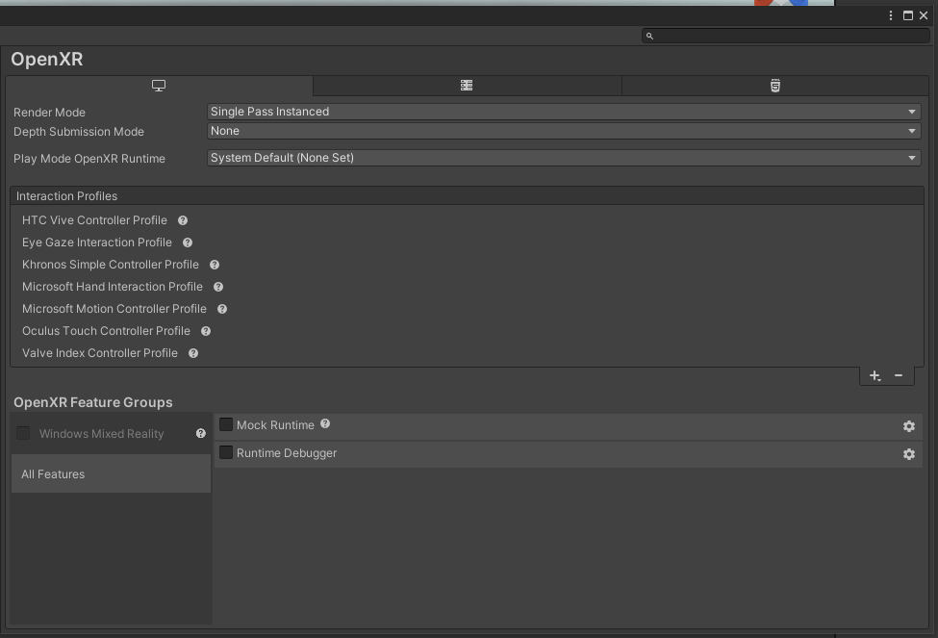

**Figure 1.17: Selection of All the Interaction Profiles**

**Step 8**: Select **Window** from the menu as shown in Figure 1.18.

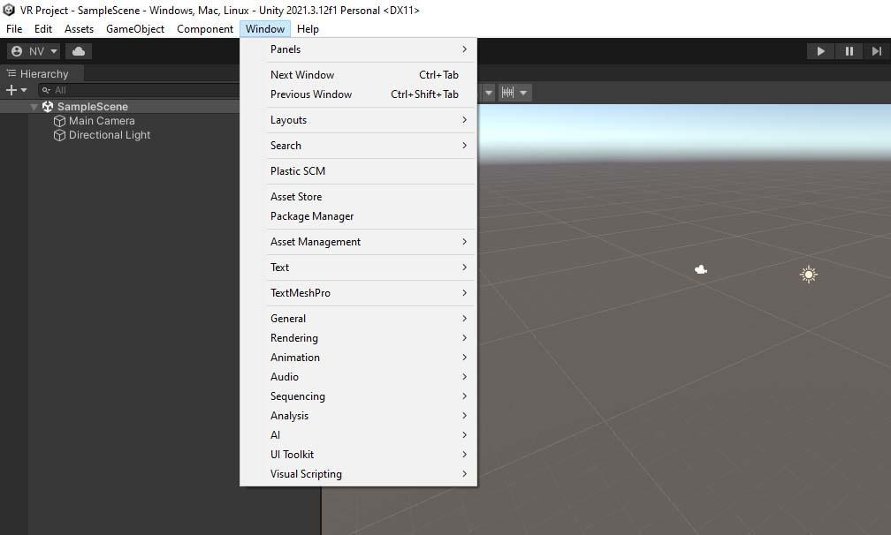

**Figure 1.18: Selection of Window’s Menu**

**Step 9**: Choose **Package Manager** from the dropdown menu as shown in Figure 1.19.

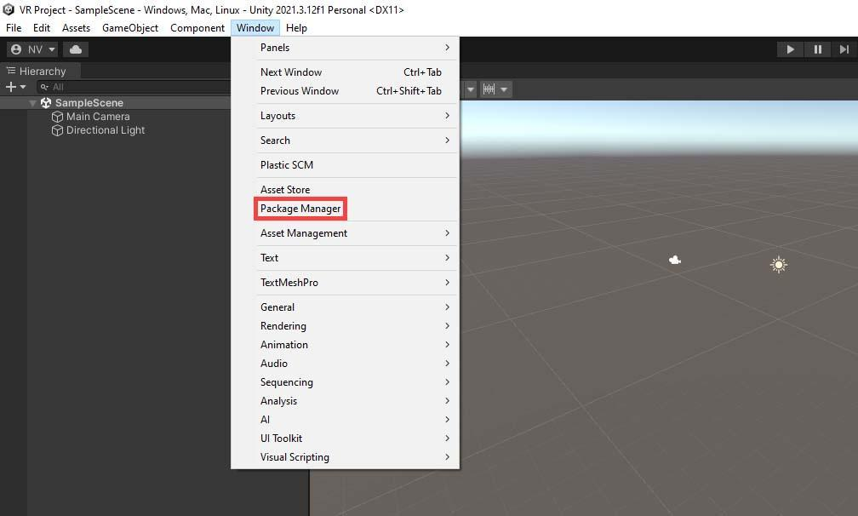

**Figure 1.19: Selection of Package Manager**

**Step 10**: Search for the **XR Interaction Toolkit** in the Package Manager and click the **Install** button to begin installing the software as shown in Figure 1.20.

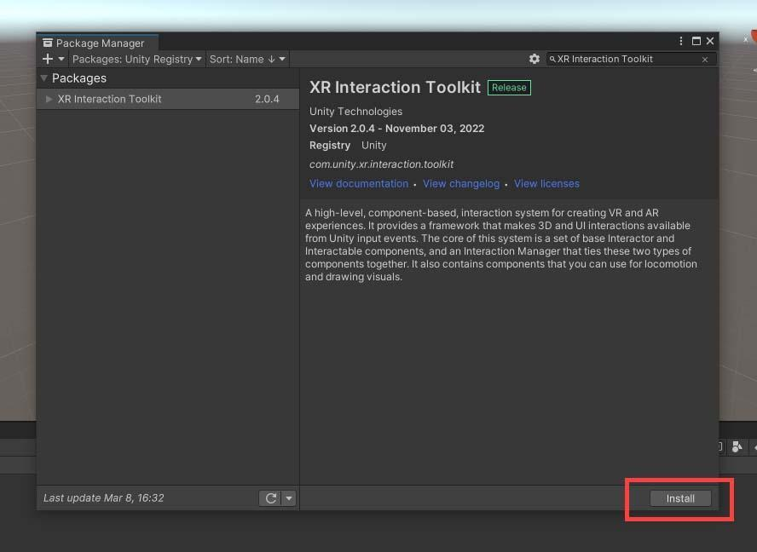

**Figure 1.20: Location of Install Button in XR Interaction Toolkit Package**

If you are creating content for the Oculus platform, you must import the **Oculus Integration** asset from the Asset Store. To do this, open the Unity Editor and search for **Oculus Integration** in the asset store as shown in Figure 1.21.

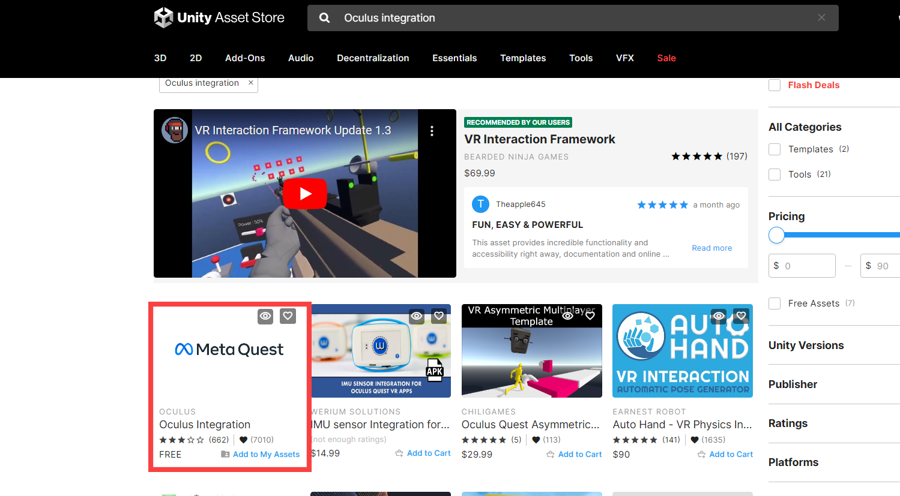

**Figure 1.21: Location of Oculus Integration Asset**

Click the **Add to My Assets** button to download the asset as shown in Figure 1.22.

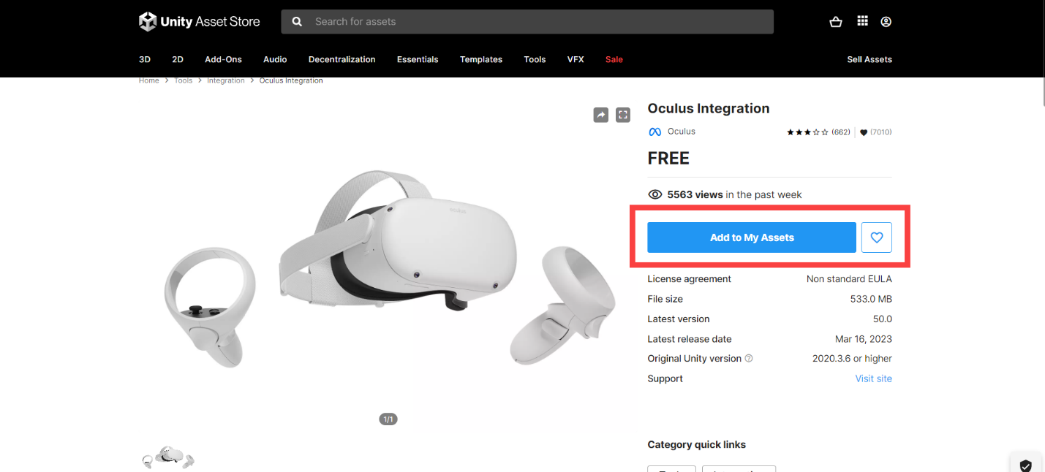

**Figure 1.22: Location of Add to My Assets Button**

Then, click the **Open in Unity** button to import the assets in the project as shown in Figure 1.23.

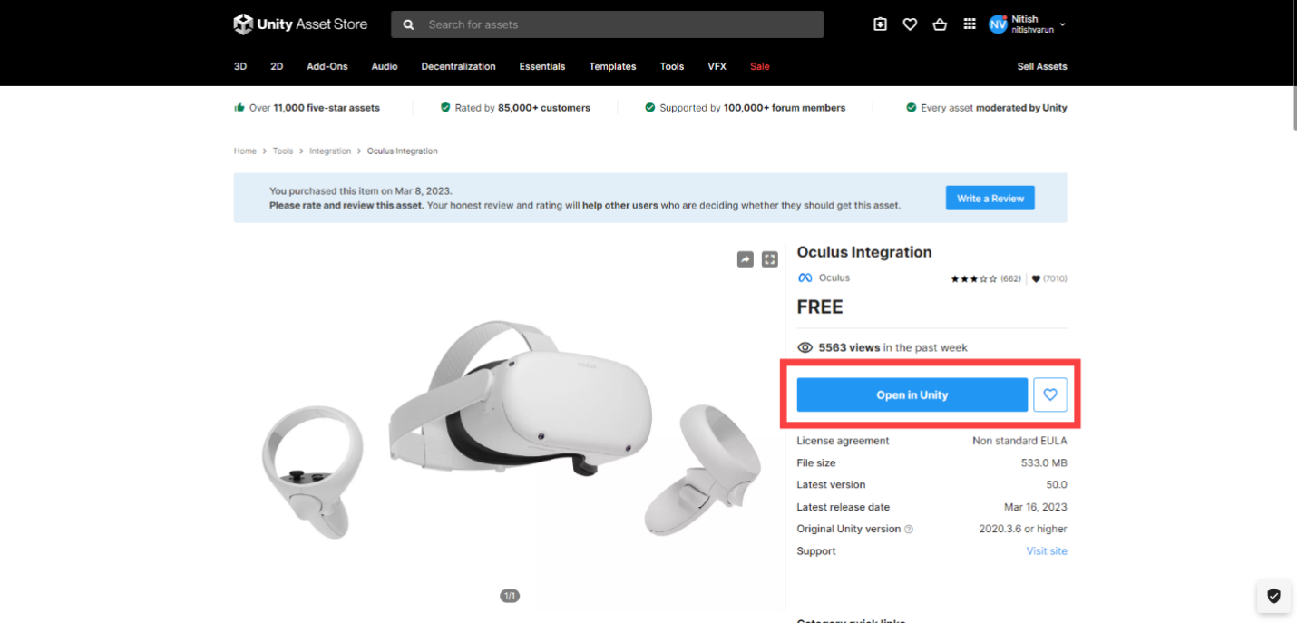

**Figure 1.23: Location of Open in Unity Button**

Depending on the requirements of the VR application, you may have to import other packages in addition to the **XR plugin** and the **Oculus Integration** package. For example, if you are creating a game, you must import the **Unity Standard Assets** package for character controllers, animations, and other game-related features.

With the right packages, one can create immersive VR experiences that captivate and engage the audience. Always keep the project organized and performance-optimized for the best results.

1.7 Summary

* VR stands for Virtual Reality and is the technology that mimics the real world or fantasy environment with the use of 3D environments inside Unity and Augmented Reality put virtual objects in the real world.
* Unity provides flexible tools and resources to create a VR application for any purpose.
* 3DOF allows rotational data tracking while 6DOF keeps track of the position as well as rotational data tracking.
* Standalone headset has everything inbuilt and is ready to use while Tethered headsets require a PC to run games.
* Unity provides a fantastic platform for developing VR applications, and setting up the necessary VR packages is a simple process.
* After creating a new VR project, you must import the necessary packages to build VR applications.
* If you are creating content for the Oculus platform, you must import the Oculus Integration asset from the Asset Store.

1.8 Check Your Progress



1. Which one of the following puts the user in a Virtual World?
2. Augmented Reality (AR)
3. Internet of Things (IoT)
4. Artificial Intelligence (AI)
5. Virtual Reality (VR)
6. Which device is generally used in combination with a VR game?
   1. Gamepad
   2. Joystick
   3. Controller
   4. Keyboard and Mouse
7. Where can you find the XR Plugin Management in Unity?
8. Edit **→** Project Settings
9. Window **→** Package Manager
10. Asset Store
11. New Project button
12. What other packages might be required to import for a game-related VR application?
13. XR Plugin Management
14. Oculus Integration
15. Unity Standard Assets
16. OpenXR
17. Why is it important to keep the project organized and performance-optimized?
18. To avoid the necessity for VR packages
19. To have a better understanding of Unity Editor
20. To create immersive VR experiences
21. To import the necessary packages

1.8.1 Answers

|  |  |
| --- | --- |
| 1 | d |
| 2 | c |
| 3 | a |
| 4 | c |
| 5 | c |

1.9 Try It Yourself

* Build your own VR Headset with cardboard and a lens.
* Identify the major differences between PSVR and PSVR2.